Clinical Practice Recommendations for Nocturnal Home Haemodialysis (NHHD)

For Review July 2021

Introduction/Benefits
The following document produced by ANNUK Home Haemodialysis Special Interest Group (HHD SIG) is intended to be a helpful guide for use by healthcare professionals for a patient being considered for, or commencing, Nocturnal Home Haemodialysis (NHHD) training. These recommendations provide the minimum standards and safety precautions required for all patients undertaking this treatment.

1. INTRODUCTION
NICE (2018) guidelines recommend that all suitable patients should be offered the choice between home haemodialysis or haemodialysis in a hospital/ satellite unit.

Nocturnal Home Haemodialysis (NHHD) is a therapy carried out over longer hours, normally whilst the patient sleeps. Typically, patients undertaking NHHD dialyse for approximately 6-8 hours from every other night to 5 nights a week with slower blood pump speeds. This allows for a slow and gentler removal of fluid and waste products, improving middle weight molecule removal.

Benefits of frequent HHD / Nocturnal HHD

It is recognised that increasing duration and/or frequency of treatment is associated with improved clinical benefits when compared to thrice weekly, conventional, haemodialysis (including superior urea and phosphate clearances, improvements with blood pressure , reduction in medication. cardiovascular benefits and a decrease in left ventricular mass. (Culleton, B; Asola, M. 2011).

There has been little improvement on survival of people with end stage renal failure over the last few decades. Research into the reasons why was undertaken about a decade ago by a number of clinicians and although there is debate about the optimum delivery of dialysis, Ercan et al (2013) highlight the ongoing research undertaken by the Frequent Haemodialysis Network (FHN), initially into short daily haemodialysis in 2010, to later research into the benefits of nocturnal haemodialysis, including the lesser known regime of three times per week nocturnal haemodialysis in 2013.

More recently Tennankore, et al (2013) in a nationally representative cohort of patients receiving HHD, identified that there was no significant difference in the relative risk of death or treatment failure when comparing NHD or SDHD with home CHD; however patients receiving NHD had better treatment survival compared with those receiving conventional HHD. There is also the possibility of an improved quality of life and enabling people to have their day free from treatment, NHS Kidney Care (2010)

Freedom to dialyse overnight means that treatment does not interfere with the person’s normal daytime activities and relieves pressure / burden through increased freedom gained from home haemodialysis.

The benefits include:

- Reduced chance of hypotensive episodes and cramping
- Treatment is more gentle and easier for the body to tolerate
- Improved recovery time
- May increase the ability to continue in employment, school, childcare and spending time with family and friends
- A greater amount of waste and fluid is removed from the blood
- Potassium and phosphates may be better controlled
- A less strict diet and fluid restriction
- A feeling of wellbeing with improved appetite
- Fluid management may be easier
- Better control of HB and less risk of renal anaemia
National Kidney Foundation (2015).

2. EDUCATION AND TRAINING.
As with all people who want to dialyse at home, a full assessment prior to training is necessary. Once a person is fully independent with their home dialysis, transition to NHHD can be discussed.

It is advisable for Home HD dialysis units to assess the person’s ability to dialyse in the home setting prior to commencing nocturnal dialysis. The actual time frame should be determined by local unit policy, to allow increased confidence and demonstration of dealing with alarms and troubleshooting.

2:1 Checklist prior to converting to NHHD

- The patient must have the machine installation set up in a bedroom or somewhere they are able to sleep.
- There is a useful dosing calculator that can be used with some dialysis machines for a nocturnal prescription .A standard prescription for low flow dialysate machines can be found online in a Nurses Guide to Implementing Best Practice in Home Haemodialysis.(2017)
https://www.edtnaerca.org/resource/edtna/files/Joint_Collaboration_EDTNA_ERCA_NxStage_Final_Folder.pdf

- Additional supplies are required for NHHD e.g. extended cycler base and filter holder, fluid leak detection, dialysate (if changed), dialyser size (if changed) blood leak detector, anticoagulant and administration pump if required.
- Standard stock requirements.
- Patient’s ability to self dialyse if doing solo dialysis.

2:2 Training schedule

Arrange for the patient to come to the centre for a ‘nocturnal session’. Normally an extended session of 6 hours minimum dialysis is performed on the home machine. It is not necessary to perform an overnight treatment as this may not be possible in a training unit.

- Patient is shown additional set up of any specific additional equipment, dialysis prescription/regimen explained, including UF rates and parameters which may need reducing particularly if a solo dialysis patient.
- Activated Clotting Time (ACT’s) or Anti Xa monitored and anticoagulation adjusted accordingly. Anticoagulation dose may need increasing to cover extended hours treatment.

3. Vascular Access

3:1 All types of vascular access can be used for NHHD.

3:3 Both rope ladder or buttonhole needling technique can be used

3:4 Single needle or double needling can be utilised for nocturnal haemodialysis NHHD. A single needle would require a double pump and additional training .

4. Care of Vascular Access
4:1 A period of in-centre competency based training on needling/central venous catheter (CVC) access, and securing access for NHHD should be undertaken.
4:2 The organisational policy or guidelines for needling and care of CVC should be followed.
4:3 If no guidelines are in place, guidelines can be accessed online in a Nurses Guide to Implementing Best Practice in Home Haemodialysis.(2017) and the Vascular Access Society of Britain and Ireland Clinical Practice Recommendations for Needling of Arteriovenous Fistulae and Grafts for Haemodialysis (2018). Available from https://britishrenal.org/aboutus/special-interest-groups/
4:4 Particular attention should be given to highlighting risks associated, and securing access. Consideration should be given to the use of commercially available monitoring systems (Renal Association. 2009, Guideline, HD 8.4.). See appendix 1 for examples of securing venous access for NHHD.

5. NHHD prescription
5:1 Dialysate

- NHHD is associated with superior clearances compared to conventional dialysis, this could increase the risk of biochemistry imbalance with an increase in treatment time, including but not limited to hypokalaemia and hypophosphataemia and hypocalcaemia.
- Careful consideration is required to the dialysate concentrate before starting nocturnal haemodialysis treatment. The Frequent Hemodialysis Network
Nocturnal Trial (Rocco et al 2011) found that higher potassium and calcium levels were required, but no increase in sodium levels were needed to maintain recommended biochemistry.

5:2 Potassium

- On commencing NHHD, conversion to a high potassium dialysate is normally required, due to the increased clearance of potassium. The patient must be competent in understanding the risk of hypo/hyperkalaemia and the importance of routine blood testing.
- Most units will have local guidelines on blood testing regime, and Renal Association provides guidance for frequency of monitoring. (BRS, 2009).

- Severe potassium imbalance can lead to;
- Muscle weakness/hyporeflexia
- Cramp.
- Electrocardiogram abnormalities.

- Serum potassium maintained between 4.6 - 5.3 mmol/L is recommended pre dialysis.
- Levels below 4 or more than 5.6 mmol/L have a greater risk of mortality. The Renal Association (2014) provides guidelines for management of hyperkalaemia.

5:3 Phosphate
- With superior phosphorous clearances, depending on treatment regime, there is a risk of Hypophosphatemia, signs and symptoms can include;

- Muscle weakness

- Bone pain
- Altered mental state

And in severe cases
- Disorientation
- Seizures
- Muscle pain
- Focal neurological deficits
- Can be asymptomatic

b. With a conventional dialysis machine for NHHD or frequent NHHD, often sodium phosphate supplementation is required to maintain normal pre/post phosphate concentrations.
c. Extra consideration should be paid to pregnant patients and those with hungry bone syndrome. Lifting phosphate dietary restrictions and reducing or ceasing binders should be considered.
d. Serum phosphate levels 1.1 - 1.7mmol/L (Steddon and Sharples 2015)
5:4 Calcium
a. The concentration of calcium in the acid can be adjusted to maintain pre dialysis serum calcium levels with normal ranges and parathyroid hormone levels (PTH) within the desirable range. Toussaint (2006) found that elevated calcium concentration were required to prevent bone density loss and post dialysis serum calcium levels may need to be in the hypercalcemic range to achieve this.
b. Signs and symptoms of hypocalcaemia;
- Intermittent muscular spasms/twitching
- Painful cramps, and tingling in the extremities
- Laryngeal spasm may cause stridor, obstructed respiration
- Convulsions may occur as hypocalcaemia lowers the seizure threshold
- Chronic hypocalcaemia may cause psychiatric effects

c. Serum Calcium 2.2 -2.5 mmol/l [Sheddon and Sharples 2015]

NICE (2018) suggest that a full dietary assessment by a specialist renal dietitian should be offered to people starting dialysis or conservative management. This should include fluid intake, sodium and potassium levels, phosphate control and protein, calorie intake and micronutrients.

Any alteration to the standard dialysis prescription will need to be reviewed by the multi-disciplinary team, with the possibility of ceasing or a reduction of phosphate binders accordingly and consideration of phosphate and calcium supplementation.

Pre- dialysis calcium and phosphate should be maintained within acceptable ranges. Blood biochemistry should be monitored pre and post treatment during the 1st and 2nd long duration treatments and then weekly for 1 month, at a minimum or more frequently if required.

The dialysis prescription should be adjusted to suit the individual needs of the patient and should be routinely assessed.

For other biochemical measures organisational protocols should be followed.

5:5 Blood and dialysate flow rates

- Local guidelines should be followed, but for units who are new to NHHD it is advised that blood flow rates of 300ml/min or less are generally suitable for most patients on NHHD.

- Dialysate flow rates should be set to reflect, individual clearance / blood chemistry, and vascular access (single or double needle)

5:6 Session timing

- NHHD is carried out whilst the patient sleeps, the duration of treatment should match the sleeping habits of the patient

5:7 Anticoagulation

- Administered either by

- Initial bolus
- Initial bolus and maintenance dose
- Maintenance dose
- Intermittent doses
- Infusion

A useful table for anticoagulation can be found online in a Nurses Guide to
Implementing Best Practice in Home Haemodialysis. (See Appendix 2)

https://homehd.edtna-erca.com/index.php/basics-of-home-haemodialysis-hcp/

6. Safety and Risk Management

Safety and risk management is covered in depth with ‘Home Haemodialysis – A nurses guide to Implementing Best Practice in Home Haemodialysis’ (2017).
It is recommended that the patient is already competent with the choice of dialysis machine and able to troubleshoot and manage any complications effectively prior to commencing NHHD.
This section looks at highlighting and managing the specific risks associated with NHHD, in detail. However, this list is not exhaustive and it remains with the dialysing unit to assess the individual patient and their ability to manage their risk when dialysing at home.
Patients should be confident with troubleshooting and what to do if they encounter problems. Patients should be encouraged to discontinue dialysis if they are concerned over their safety or feel unwell.
Patients should have access to a telephone to seek support from medical or technical support/advice or the emergency services if required. Each unit will have different systems in place for overnight support, such as an on-call service, or telephone support from the renal ward.

Specific Safety and risk concerns;
- Blood loss
- Anticoagulation - see NHHD prescription
- Access complications
- Air embolism
- Intradialytic hypotension
- Biochemistry imbalance - see NHHD prescription

6:1 Blood loss and venous needle dislodgement/CVC dislodgement

- One of the main risk factors for NHHD, although relatively rare, is dislodgement of access. This can apply to both venous access or central venous catheter access (CVC).
- There are a number of proprietary venous blood leak detectors available, as blood loss from the venous line may not trigger the venous alarm parameters and the blood pump will continue.
- Any safety equipment must be checked and correctly used.
- Blood leak detector equipment can be used with venous access and CVC access.
- Any safety equipment use and testing should form part of the in-centre training and the patient should be aware of how to correctly use and test the safety equipment.
- Safety equipment must be tested prior to each use as per the manufacturer's instructions.
- An enuresis alarm pad and sensor can be used as a secondary backup to the primary blood leak.
- Venous alarm parameters can be reduced to increase the sensitivity of venous pressure changes.

6:2 Securing the needles and lines for NHHD.
- All arteriovenous fistulas/grafts needles can be secured with an adhesive tape as per the local guidance to hold the needle in place and minimise movement.
- Entry points of the cannulation sites can also be covered with a sterile dressing to keep the wound clean and free from debris.
- The blood lines should not be taut but looped and taped to the skin at the wrist or shoulder to minimise tension on the needles and connection points. A line clip can be used if the patient wears a pyjama or top.
- A tubular dressing can secure the lines in place, covering both needles but not so tight as to constrict the flow through the vascular access.
- The limb with the vascular access should be rested in a comfortable position, ideally supported by a pillow, to help reduce movement. If the vascular access is on the leg then a bed cradle can be used to reduce the weight of bedding.
- Some blood lines provide a clip to secure the venous blood line to the venous needle, this type of clip is recommended to help prevent the luer-lock unintentionally coming loose, alternatively a piece of tape can be placed over the bloodline luer-lock adhering it to the needle to reduce the chance of unintentional disconnection.
(See appendix 1 for example of securing the needles.)
6:3 Blood leak sensors and safety equipment
- It is not only from the needle and needle connections that blood loss can occur, it is advisable that every patient who undertakes nocturnal haemodialysis has fluid leak detection equipment on the haemodialysis machine.

6:4 Anticoagulant for long duration haemodialysis
- See Dialysis prescription and adjust accordingly.

6:5 Access complications, including life threatening haemorrhaging (LTH).
- The British Renal Society Vascular Access SIG & VASBI have produced guidelines on how to prevent and manage LTH available at https://britishrenal.org/quality-improvement-clinical-practice/brs-guidelines/
- All patients should be trained how to deal with LTH and know who to contact
- If blood is leaking from around the needle during treatment, gently place a sterile piece of gauze over the needle entry point. If bleeding continues, discontinue dialysis and contact the home haemodialysis team to discuss the safety of continuing NHHD. It may be necessary to contact an on-call team, depending on local policy for out of hours advice.
- Access related complications, are often preventable with good assessment of the fistula/graft and with good needling technique.

6:6 Air embolism
- A rare but serious adverse event that can potentially cause death, the risk of which may be increased due to the lack of supervision, troubleshooting and managing air alarms whilst the patient could be drowsy from being disturbed from sleep.

The following events can all result in an air embolism;
- Unintentional disconnection
- A CVC not clamped when a cap is removed
- Mis-management of an air alarm
- Incorrect or failed priming of the bloodlines
- Poorly secured connectors
- Defective air detection alarm

- The patient must be able to manage air alarms effectively and safely and if an air embolism is suspected, the blood pump must be stopped and the lines clamped.
- The patient must telephone 999 requesting paramedic attendance immediately if an air embolus is suspected, stating they are a dialysis patients on dialysis and they have accidentally given themselves air.
- The patient must take position in the Trendelenburg position, or left lateral position.
- Signs and symptoms of an air embolism in the cerebral venous system include;

- Confusion
- Distorted vision disturbances
- Coma

- Signs and symptoms of a pulmonary air embolism include;

- Chest pain,
- Dyspnoea,
- Coughing,
- Cyanosis
- Cardiac arrest.

- Prevention, recognition and management of an air embolism is incorporated into NHHD training, especially with patients with CVC access.

6:7 Blood pressure control and Intradialytic hypotension
- Increasing the frequency and/or duration of HD treatment improves blood pressure control with fewer anti-hypertensive medication and importantly the risk of the development of significant intradialytic hypotension (IDH) is reduced with NHHD due to the duration of the treatment and associated low ultrafiltration rates. (Walsh et al 2005) (Culleton et al 2011).
- The patient must be assessed as competent in assessing the target weight and agree to contact the appropriate healthcare professional for a target weight and/or medication review at the earliest opportunity. Vital signs are to be recorded pre dialysis, within 15 minutes of commencing dialysis and post dialysis as a minimum.
- The patient should adhere to a maximum hourly ultrafiltration rate for dialysing nocturnally that has been assessed as safe by the renal team. Evidence suggests that fluid exceeding 10ml/kg/hr increases the risk of morbidity and mortality (Flythe et al 2001) and concerns achieving this will need to be discussed.
- These measures do not prevent excessive ultrafiltration volumes particularly over 6-8 hour treatments, the patients understanding of target weight and the potential causes of low blood pressure should be regularly assessed.
- The Renal consultant should review regular medications prior to transferring home, with particular consideration to anti-hypertensive medications.
- The patient should understand the potential causes of hypotension, the signs and symptoms and the management of low blood pressure. Regular fluid status reviews and competencies assessed.
- Patients and their dialysis partners should be aware and able to contact emergency services at any time during treatment should this be necessary. In addition, the individual organisation should provide relevant points of contact within the service with accessible times.

6:8 Biochemistry imbalance
- Review dialysis prescription. Consider altering dietetic advice and increase dietary potassium, phosphate, and magnesium.

7. On-going support

All patients at home should be offered regular contact from a member of the home team which can be a home visit, attending a nurse led clinic, or telephone/Skype call/NHSone, and email support. With some dialysis machines there is the possibility of using IT systems that collects machine data which is transmitted directly to health care teams enabling remote monitoring of patients dialysing at home.
- The renal technicians may provide technical support for care and maintenance of the dialysis machine and other equipment supplied, depending on choice of home machine.
- Following conversion to NHHD a home visit should be scheduled within the first week, and then monthly. A risk assessment rating tool should be used to determine if the patient requires extra support be it in the form of a phone consultation or additional visits. (See appendix 3 for example of risk assessment)
- Frequency of continuing contact and support will depend on the patient and local policy. A minimum of monthly check-ups are common in most Home HD Units. Consultant clinics are usually attended quarterly.
- If possible there should be the option to offer respite for patients and carers if the need arises. This can be by offering dialysis at the training centre or the local dialysis unit.

References:

British Renal Society VASBI Recommendations for Managing Life-Threatening Haemorrhages from AV Fistulae / Grafts [online] http://vo2k0qci4747qecahf07gktt.wpengine.netdna-cdn.com/wp-content/uploads/2016/10/Recommendations-for-Managing-LTH-of-AVF-and-AVG-1.pdf 11/3/2018
British Renal Soceity - VASBI Clinical Practice Recommendations for Needling of Arteriovenous Fistulae and Grafts for Haemodialysis http://vo2k0qci4747qecahf07gktt-wpengine.netdna-ssl.com/wp-content/uploads/2018/09/Clinical-Practice-Recommendations-for-Needling-of-Arteriovenous-Fistulae-and-Grafts-for-Haemodialysis.pdf

Culleton, B. Asola, M. (2011) The impact of short daily and nocturnal hemodialysis on quality of life, cardiovascular risk and survival. Journal of Nephrology 2011; 24(04): 405-415

Ercan Ok, CC., Lacson Jr, E., Kerr PG., Kerr, G., Misra, J M. Thrice-weekly nocturnal hemodialysis: the overlooked alternative to improve patient outcomes. Nephrology Dialysis Transplantation, Volume 28, Issue 10, October 2013, Pages 2447–2455, https://doi.org/10.1093/ndt/gft078

Flyth, J.E., Kimmel, S.E., Brunelli, S.M., (2001) 'Rapid fluid removal during dialysis is associated with cardiovascular morbidity and mortality', Kidney International, 79(2), pp. 250 - 257.

Home Haemodialysis – A nurses guide to implementing best practice in home haemodialysis (2017). EDTNA/ERCA. Switzerland. http://homehd.edtna-erca.com
Home Haemodialysis – A nurses guide to implementing best practice in home haemodialysis (2017) 9.2.3 Follow-up after a serious adverse event. Share

Kovesdy, c., Regidor, D.L., Mehrotra, R., Jing, J., McAllister, C.J., Greenland, S,. Kopple, J.D., Kalantar-Zadeh, K., (2007) 'Serum and Dialysate Concentrations and Survival in Hemodialysis Patients', Clinical Journal of American Society Nephrology , 2(5), pp. 999-1007.
Kumwenda, M, Mitra S, Reid, C, Clinical Practice Guideline. 6th Ed (2015). Vascular Access for Haemodialysis UK. Renal Association. www.renal.org/guidelines
NHS Kidney Care (2010). https://www.kidney.org.uk
The National Service Framework for Renal Services Part 1: Dialysis and Transplantation, Department of Health, London, UK, January 2004. (www.doh.gov.uk/nsf/renal/index.htm) 2 Clinical Standards for Adult Renal Services, NHS Quality Improvement

https://britishrenal.org/quality-improvement-clinical-practice/brs-guidelines/
NICE (2018). https://www.nice.org.uk draft guidelines

The Renal Association - haemodialysis

https://renal.org/wp-content/uploads/.../Module_3a_-_Haemodialysis_-_4th_Edition.pdf accessed online 22/05/19

Rocco, M., et al (2011) 'The Effects of Frequent Nocturnal Home Hemodialysis: The Frequent Hemodialysis Network Trial.', Kidney International, 80(10), pp. 1080-1091

Steddon, S., Sharples, E., (2015) ‘CKD Mineral and Bone Disorders. Renal Association Guidelines’, Nephron Clinical Practice, 2011;118(suppl 1):c145–c152

Tennankore, K K. Yingbo, N A. Wald, R. Chan, C T. Perl, J.Short daily-, nocturnal- and conventional-home hemodialysis have similar patient and treatment survival. Kidney International (2018) 93, 188–194

Toussaint, N., Boddington, J., Simmonds, R., Waldron, C., Somerville, C., Agar, J., (2006) 'Calcium phospate metabolism and bone mineral density with nocturnal hemodialysis', Hemodialysis International, 10(3), pp. 280-286

Walsh, M., Culleton, B., Tonelli., Manns, B. (2005) 'A systematic review of the effect of nocturnal hemodialysis on blood pressure, left ventricular hypertrophy, anaemia, mineral metabolism, and health-related quality', International society of nephrology, 67(2005), pp. 1500-1508

Wild J, Fluck, R., (2019) Kidney Failure Explained 6th Ed. Class Publishing. Bridgewater.

APPENDIX 1: Securing the needles/CVC Access

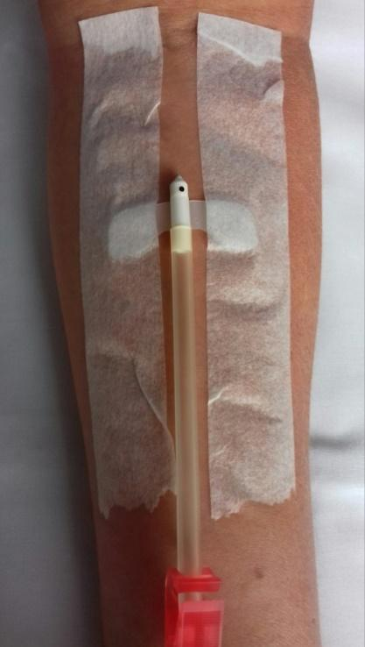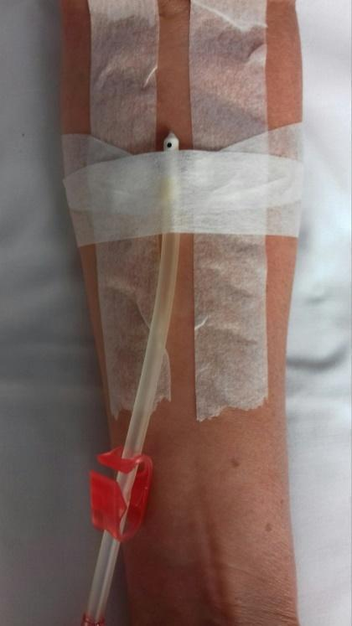

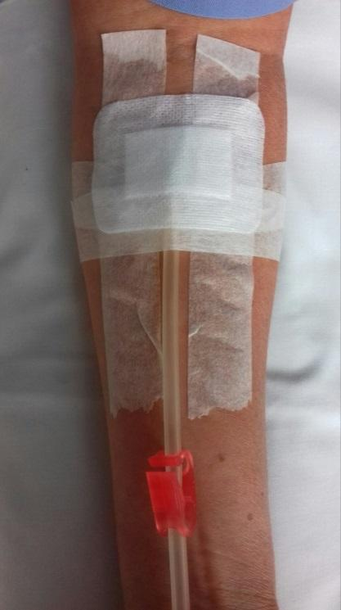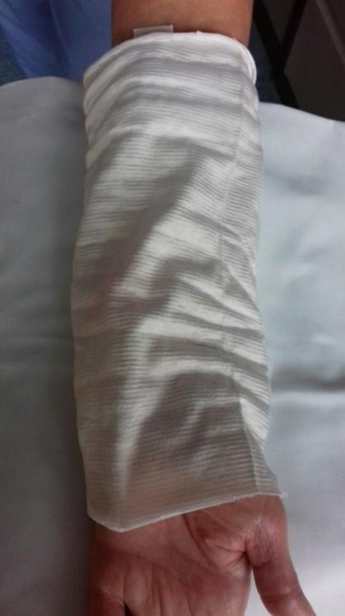

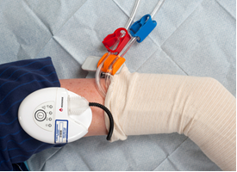

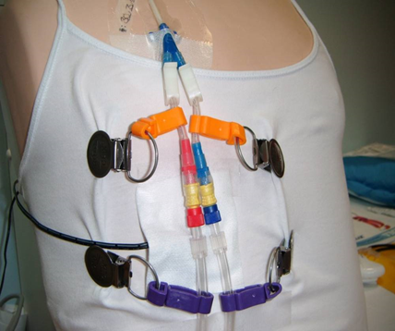

APPENDIX 2: Anticoagulation Chart
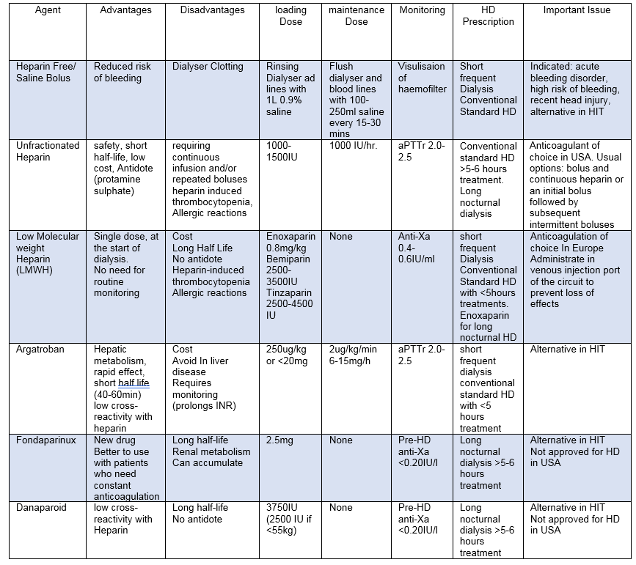

APPENDIX 3 :Risk Assessment
Home Haemodialysis Operational Checklist

Name | Jan. | Feb. | March | April | May | June | July | Aug. | Sept. | Oct. | Nov. | Dec.
Equipment
Delivery
Monthly Blood Test
Sharps / Safety
Problems / Concerns
Action / Plan

List of abbreviations

ACT. Activated clotting time. This test is measured in the number of seconds it takes for a blood clot to form: 70 to 120 seconds is the usual amount of time for blood to clot without heparin. 180 to 240 seconds is the usual amount of time for blood to clot with heparin. This is called the therapeutic range.

Air embolism. An air embolism takes place when bubbles of air are introduced into circulating blood. Air embolisms caused by surgery, anaesthesia or other medical procedures can be difficult to treat. Treatment is usually needed to support the heart, blood vessels and lungs.

ANN-UK. Association of Nephrology Nurses UK
AVF. Arteriovenous fistula. The best type of long-term access is an AV fistula. A surgeon connects an artery to a vein, usually in the arm.
AVG. Arteriovenous graft is a man-made tube that is inserted to connect an artery to a vein.

Buttonhole needling - technique of inserting dialysis needles.

CHD. Conventional haemodialysis. Usually three times per week for four hours per session.

CVC. Central venous catheter - in this case used to access circulation for the purposes of dialysis.

HB. Haemoglobin. Protein responsible for transporting oxygen in the blood

HD. Haemodialysis. A medical procedure to remove fluid and waste products from the blood and to correct electrolyte imbalances.

HHD. Home haemodialysis. A medical procedure to remove fluid and waste products from the blood and to correct electrolyte imbalances. completed in the home setting.

LTH. Life threatening haemorrhage. Profuse bleeding occurring from a fistula or graft site unexpectedly.

NHD. Nocturnal haemodialysis. A haemodialysis regime that allows patients to dialyse at night. Instead of the usual four hour dialysis session three times per week patients dialyse for approximately 8 hours, four to six nights per week, at a slower pump speed. removing excess fluid, salt and wastes from the blood

NHHD Nocturnal home haemodialysis. A haemodialysis regime that allows patients to dialyse at home at night.

NHS Kidney Care. Kidney patient support charity.
NICE. National Institute for Health and Care Excellence
SDHD. short daily haemodialysis. The dialysis schedule consists of daily hemodialysis (five to seven days per week) provided for a duration of 1.5 to 3 or more hours per session.

NKF. The National Kidney Foundation. Kidney patient support charity.

Rope Ladder technique.. Rotation of the needle placement sites each time a patient has hemodialysis.

SIG Special Interest Group. Small specialised group attached to larger ANN-UK group.

Trendelenburg Position. The body is laid supine, or flat on the back on a 15-30 degree incline with the feet elevated above the head.

